Screenshots for FGCU Virtual Lab Assignment (Landon Trevisani)
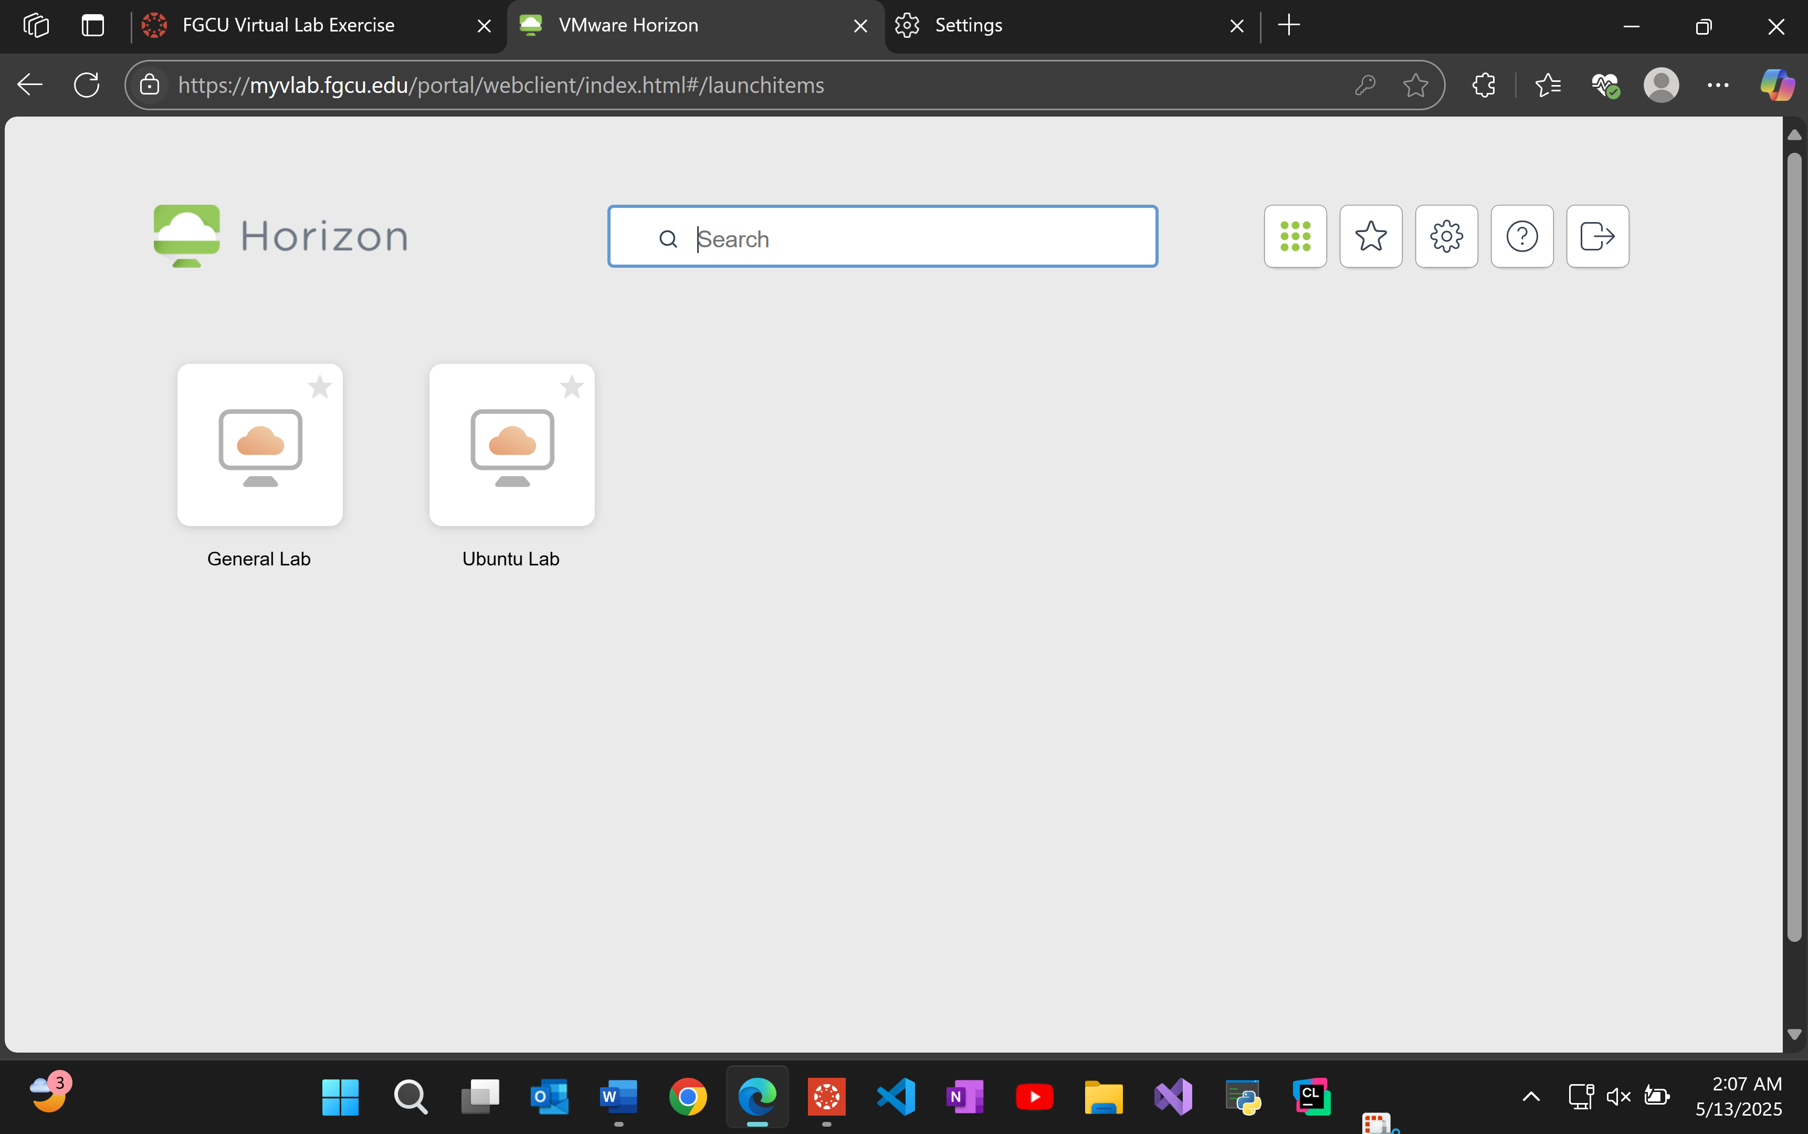

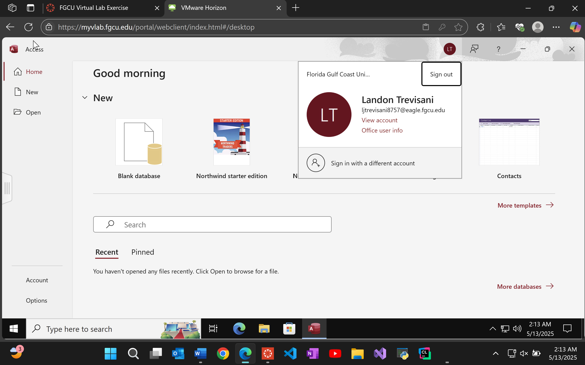

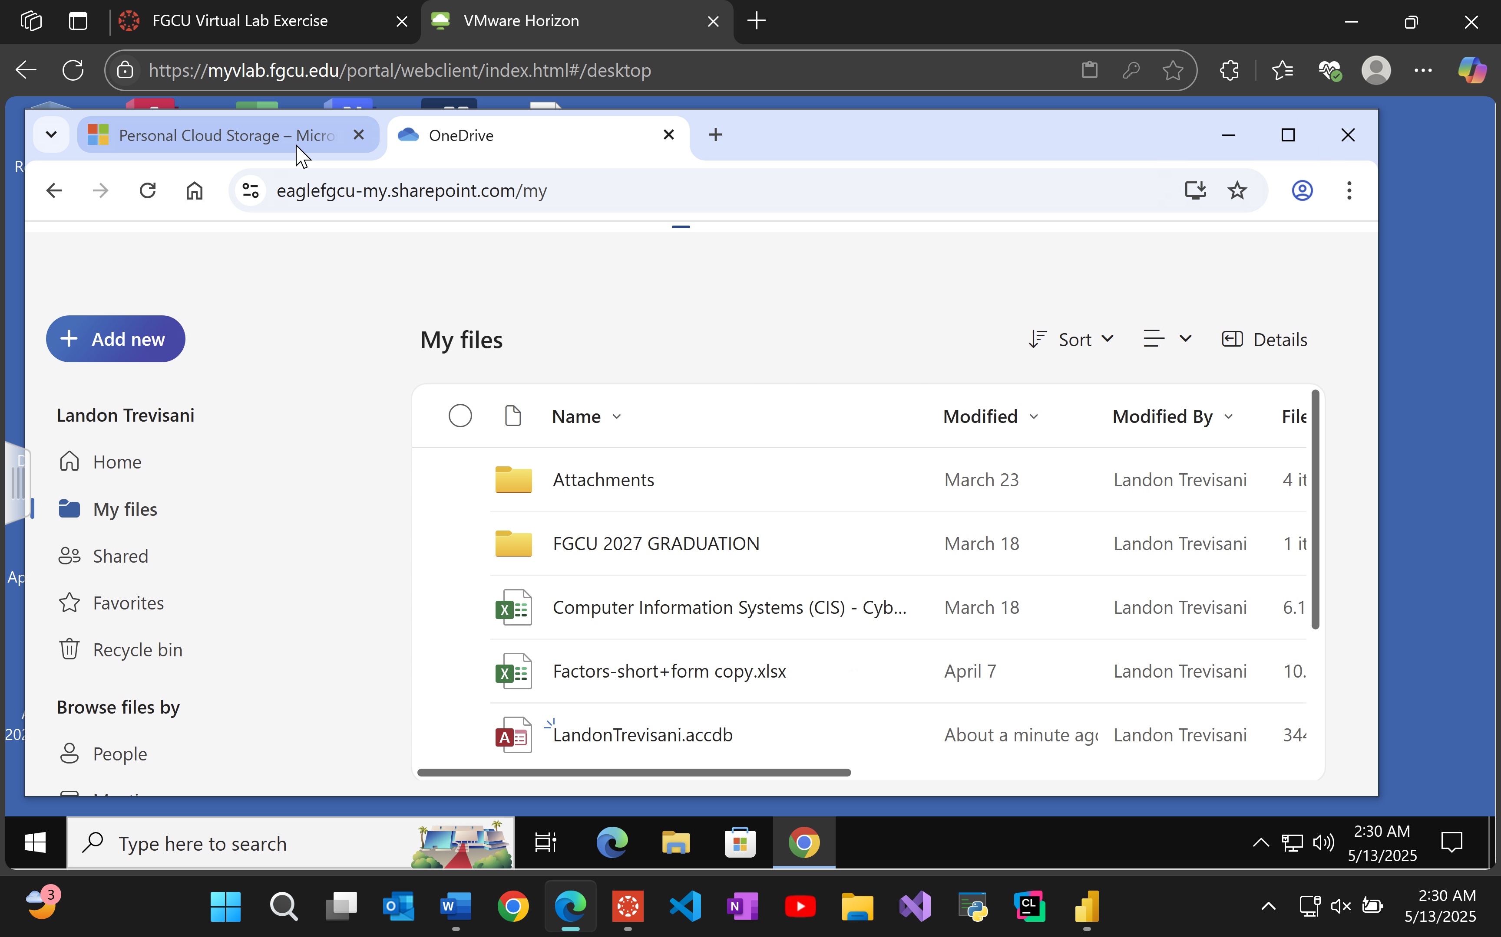
According to the article, Virtual Machines and Virtualization technology can benefit businesses in many ways. First, all desktop management occurs from a central location, meaning that there is no down time in between updates or an annoying IT guy coming to fix something specifically on your system to configure the infrastructure (VDI). The IT teams can release updates all at once instead of working on dozens of machines individually. The hardware requirements are also not as demanding as most of the heavy lifting is done by the central server. Updates can also be released on the same day and be rolled back to previous versions if there were ever any issues. This allows companies to get back to work as soon as possible incase of a data center failure.

